Name ________________________________ Somers Science Research

Research Plan Guidelines

- The entire research plan must be written in FUTURE TENSE!
- Size 12 font, 1.5 spacing, Times New Roman font, page numbers
- APA formatting
- APA headings
- No cover page
- Must include items a-i as indicated below
- Items 1-4 are subject-specific guidelines and are to be included in your research plan as applicable

Items a-h below are required for your research plan.
- Project Title
  - State your project title.

- Rationale
  - Level 1 heading. Include a brief synopsis of the background that supports your research problem and explain why this research is important. If applicable, explain any societal impact of your research.

- Hypothesis/Objectives/Engineering Goals/Research Question(s)
  - Level 1 heading. List all hypotheses/objectives/goals/research questions.

- Methodology
  - Level 1 heading. Detail all procedures and experimental design. Describe only your project, do not include work being done by mentors or others.

- Role of Student and Mentor
  - Level 1 heading. Clearly describe what you are going to do, what your mentor is going to do and what others are going to do.

- Data Collection
  - Level 1 heading. Include all methods for data collection.

- Data Analysis
  - Level 1 heading. Describe the procedures you will use to analyze the data/results.

- Risk & Safety
  - Level 1 heading. Identify any potential risks and safety precautions needed. If none are present, that must be stated as well.

- References
  - Level 1 heading. List major references (e.g. science journal articles, books, internet sites) from your literature review. If you plan to use vertebrate animals, one of these references must be an animal care reference. List references in alphabetical order by last name using APA format.

Items below are subject-specific guidelines for additional items to be included in your research plan as applicable.

- If your project includes human participants research, add these additional items in your research plan as level 1 headings.
  - Participants: Describe age range, gender, racial/ethnic composition of participants. Identify vulnerable populations (minors, pregnant women, prisoners, mentally disabled or economically disadvantaged).
  - Recruitment: Where will you find your participants? How will they be invited to participate?
  - Risk Assessment: What are the risks or potential discomforts (physical, psychological, time involved, social, legal, etc.) to participants? How will you minimize risks? List any benefits to society or participants.
  - Protection of Privacy: Will identifiable information (e.g., names, telephone numbers, birth dates, email addresses) be collected? Will data be confidential/anonymous? If anonymous, describe how the data will be collected. If not anonymous, what procedures are in place for safeguarding confidentiality? Where will data be stored? Who will have access to the data? What will you do with the data after the study?
  - Informed Consent Process: Describe how you will inform participants about the purpose of the study, what they will be asked to do, that their participation is voluntary, and they have the right to stop at any time.
  - In your methods section, answer these questions: What will participants be asked to do? Will you use any surveys, questionnaires or tests? What is the frequency and length of time involved for each subject?

- If your project includes vertebrate animal research, add an additional Tier 1 heading titled “Vertebrate Animal Research” and include the information below.
  - Discuss potential ALTERNATIVES to vertebrate animal use and present justification for use of vertebrates.
  - Explain potential impact or contribution of this research.
  - Detail all procedures to be used, including methods used to minimize potential discomfort, distress, pain and injury to the animals and detailed chemical concentrations and drug dosages.
  - Detail animal numbers, species, strain, sex, age, source, etc., include justification of the numbers planned.
  - Describe housing and oversight of daily care.
  - Discuss disposition of the animals at the termination of the study.

- If your project includes potentially hazardous biological agents research, add an additional Tier 1 heading titled “Potentially Hazardous Biological Agents Research” and include the information below.
  - Give source of the organism and describe BSL assessment process and BSL determination.
  - Detail safety precautions and discuss methods of disposal.

- If your project includes hazardous chemicals, activities, & devices, add an additional Tier 1 heading titled “Hazardous Chemicals, Activities, & Devices” and include the information below.
  - Describe Risk Assessment process, supervision, safety precautions and methods of
Disposal.

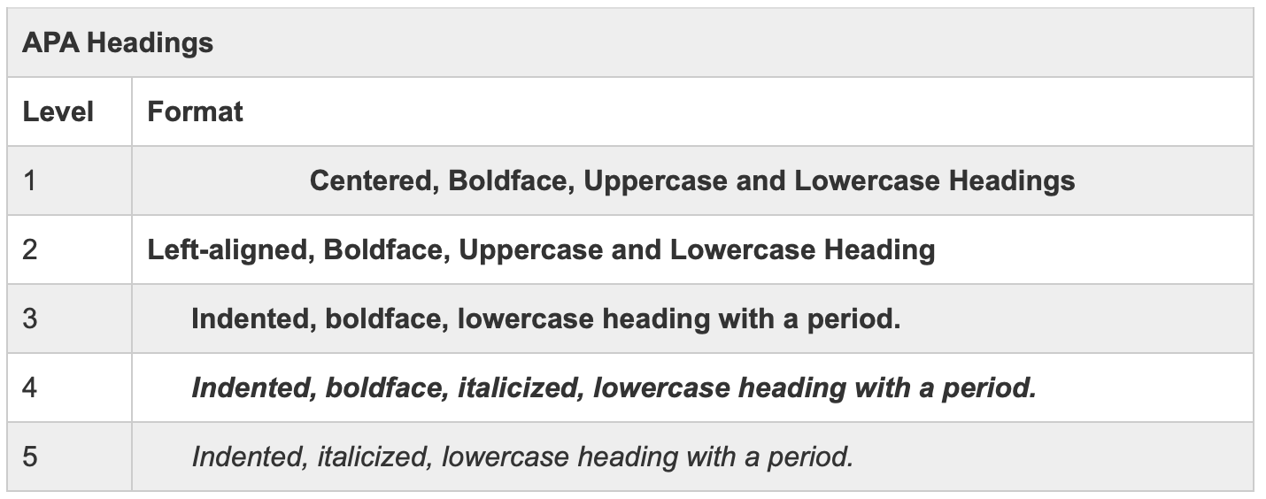
APA Heading Example

